**ABSTRACT**

Numerous recommendation techniques have been already proposed and encapsulated into several e-business applications, aiming to perform a more accurate evaluation of the existing information and accordingly augment the assistance provided to the users involved. Intelligent Transportation Systems are changing the way people plan a journey and travel around the world (or even in a city). Also mobile devices are becoming an inseparable part of our lives and personalized location-based mobile services are gaining more and more popularity. So we are mixing the technology of a Mobile Phone and the smartness of Intelligent Transportation Systems to create a SMART TRANSPORT RECOMMENDER SYSTEM (Travel Bania) for people. The scope of this paper is to illustrate the design choices and the implementation of a personalized Smart Transport Recommender System, built for the citizens for regular use. Using this system the user can obtain the most appropriate mode of transport to travel between two arbitrary points in the city according to his/her priority (Cost, Comfort and Time).

**Chapter 1**

**INTRODUCTION**

For making a good decision, we require possessing sufficient information and today’s technologies especially the internet enables us to easily obtain it. Gradually we are depending upon technologies for our selection in any situation. Transportation systems are also advancing with the help of technology. Initial steps for travelling from one location to another location necessitate different essential decisions like which route to select or most appropriate mode of transport. This creates an issue of selection. This arises because of heterogeneous preferences of users/trippers (E.g. duration of journey, cost involved and the comfort level). So it is necessary to assist the customer by evaluating his desires and help him in making final decision. There are various alternatives; therefore an appropriate recommender system is needed. Acquiring suggestions from reliable sources is an essential component of the natural procedure of human thought processing. Our aim is to find the optimal mode of transport which satisfies the user’s preferences of comfort level, expense, and duration of journey. Using this system the user can obtain recommendations for modes of transport between two arbitrary points in the city directly on his smart phone. According to the definition of the recommendation systems they are used to produce or give guidelines to the user in a

personalised way.

Recommender systems produce suitable recommendation in one of the following ways:

● Collaborative Filtering (CF): Past ratings of other users are collected and used for recommending items to a new user in collaborative filtering.[7]

● Content-based recommending: In this approach content of those items are analysed which user has liked once or the items complimenting the preferences of the user. [7]

● Knowledge-based recommending: This recommender system works differently from the above mentioned approaches, it mainly focuses on the external knowledge of the item assortment, criteria used for suggestion and user requirements.

● Hybrid approaches: It is a combination of above mentioned three approaches. [7] In our proposed system we will be using a hybrid approach.

Our motto is to combine the features of collaborative filtering and knowledge based filtering. The output of the combined approaches will be used to suggest/recommend mode of transport to the user according to his preferences. Firstly, for the purpose of data collection, we will create a knowledge base and add user profiles for further use. After the collection of sufficient data, we will use collaborative recommendation, in case where user is not satisfied with the results of the algorithm present in knowledge base users with similar behavior are searched by collaborative filtering and recommendations are made accordingly.

**Chapter 2**

**LITERATURE REVIEW**

One of the popular application that everyone has in their mobile phone is Google maps (maps.google.co.in). It provides real-time GPS navigation, traffic, transit, and details about millions of places, such as reviews. Another popular application is Citymapper (citymapper.com). It is a trip planner application that combines all transportation modes to find the best routes like walking, subway, bus, train, rail, ferry, Uber, taxi & cab and bike share all in real-time, including bus and train schedules and disruptions. Another popular application Transit Direction by Moovit (moovitapp.com) , it constantly updates as transit operators change schedules or alter service, so that the user don't end up at a station that is closed, or waiting for a bus that isn't coming. What all these application do in common is that they find the best routes from Point A to Point B for most modes of transport. They provide real time navigation details and real time updates of transits. The biggest problem with the existing system is that, although it furnishes routing data but that data may not be completely customized, personalized, and suitable for the customer. Also every time the user might not be interested in the shortest possible route, what if the transit on that route is the most expensive?

*Personalized Mobile City Transport Advisory System* [1], a system that helps users to find a personalized path connecting two arbitrary points of a city using the city transport means and walking. The paths are illustrated by listing the various connections that the user must take to reach the destination using public transport means and walking. The recommendations are selected in a personalized way, using a knowledge-based recommendation technology, and for each user the suggestions are computed according to their travel-related preferences. The limitations of this system are that it is not having an interactive interface. Also it is taking a lot of input from the user (i.e. not suitable for the user having time limitations or is in hurry)

Another project *Recommendation for Local Transportation System using Ambient Intelligence* [5] proposes design of a context-based recommendation system for local transportation system in order to provide an accurate ETA (Estimated Time of Arrival) and ETD (Estimated Time of Departure). It generates recommendations for an alternative path to traveller’s destination to save time in case of adverse situation of traffic on a particular route. Provide the required recommendation alternate means of transportation. But it is completely dependent on another system i.e. Intelligent Transport System (ITS). Also it doesn’t consider all modes of transport. And most importantly no option for user to enter his/her preferences.

*An Integrated Transport Advisory System for Commuters, Operators and City Control Centres* [4] is a proposed system that not only has the user interface window but also the transit operator window and a control centre window. In the user window each individual is presented the personalized information on their mobile device at the time of offering a travel plan as well as the dynamic updates in transit.

The driver view updates interactively under the instruction from the control centre. In case of an on-road event being reported by a driver or by other public service sources, an alert is instantly triggered on the control centre dashboard that offers micro level view to monitor the incidents and allows a human expert to take actions enabled within the software application. The control centre views provide instant updates on ground incidents. It is possible to drill down to micro information of routes, zones, vehicles, passengers and incidents. The control centre can connect with and assist the drivers on move to help address traffic incidents. A substantial amount of intermodal non-personalized information is provided on the electronic displays on the hubs. The limitation of the system is that it only focuses on public transport and don’t consider options like car pooling and or personal mode of transports.

**Chapter 3**

**THEORETICAL MODELING**

**3.1 Proposed System**

The aim is to build a system that is able to come up with appropriate recommendations on the basis of user

Preferences/situation by understanding the users' context in the system.

Proposed system has following key objectives:

• Outline a transport system that suggests the optimal mode of transport after taking all of the user preferences.

• System should be able to suggest alternate routes to the final location of the user in case of unpropitious situations like extreme traffic on a particular path with the intention of saving time.

• It is also able to suggest alternate options of the transport modes.

• In required cases we will use collaborative based filtering for better suggestions as it may be possible that multiple users are showing same behaviour.

• After the user will enter its preference for cost, comfort and time, the program will use its algorithm to find the best mode of transport. It’ll also apply the concepts of recommender systems to give the best recommendation. Not only the best but also the second best and so on.

***Basic approach used:***



In real world vehicles with crossing paths need to access the core area of intersection mutually exclusively, like only one of lane 0 and lane 2 can pass the intersection core area. Lanes which cannot access the intersection core area at same time are conflicting lanes and lanes which can access the intersection at same time are concurrent lanes. Vehicles in conflicting lanes cannot access the intersection at same time and vehicles in concurrent lanes can access the intersection core area at same time, vehicles in same lane can access the intersection but in a queue.

“∝” is used to represent conflicting lanes and “≈” to represent concurrent lanes, example L0 and L1 are concurrent and relationship can be represented as L0≈L1, similarly L5 and L6 are conflicting lanes and relationship can be represented as L5∝ L6.

The concurrent and conflict relationship can be shown by this conflict graph in Fig 3.1. The vertices represent lanes. Two lanes/vertices which are connected directly through a single edge are conflicting and lanes/vertices which are not directly connected are concurrent lanes.

Lanes that are on the same face and not connected directly by an edge are strongly concurrent to each other and represented as L0≅L4.

It basically is using a hybrid approach to suggest a mode of transport. Basic steps represented by above model are:

- Initially user profile is created.

- Then take location from the user.

- Then parameters like cost, time and comfort is entered by the user.

- Using the algorithm from the knowledge base and extracting required data, proposed system will try to collect the whole information of that particular user.

- In some cases past rating of other users can also be considered i.e. use of collaborative filtering and mode of transport is suggested according to calculative priority of the homogeneous users.

- User feedback is also collected in the efficient manner for further use.

**3.2 Pseudo code:**

Knowledge based pseudo code:

This pseudo code is designed for a city. Here corresponding to every mode of transport is an element in every array with the same index. For example if Time[i] represents time of bus then Cost[i],Comfort[i],etc also related to bus.

For Cost:

$$(100- \left(rank\left(a_{ik}\right)-1\right)*\frac{100}{N})*t_{k} = b_{jk}$$

$$c_{ik} = g(b_{jk})$$

$$final = \sum_{k=1}^{3}{}\sum_{i=1}^{N}{c_{ik}}$$

$a_{jk}$ =column vector

$b_{jk}$ =column vector of weighted cost in a sorted order.

$c_{jk}$ =column vector of weighted cost in original order.

$t_{k}$ = parameter from the user.

Where

$k=1$ represents cost, $k=2$ represents time and $k=3$ represents comfort.

$rank()$ gives the rank of all the modes of transports from 1…*N* where lower rank signifies better consumer preference

and sorts the array in increasing order.

For $k=3$ sorting will be done in decreasing order

$g()$ is defined such that index of $a$ and $c$ same

$final$ = summation of weighted values for every mode of transport for it’s respective parameter.

Mode with the highest value in $final$ is most suitable for the user according to his/her preferences.

Collaborative filtering pseudo code:

For the purpose of collaborative filtering we will use kNN(k-nearest neighbours) algorithm. kNN can be used for both classification and regression problems[10]. We will use it to find the users with homogeneous deportment.

This pseudo code is for finding only one user with similar input parameters as of new user.

1. Define following variables:

${ datamatrix}_{(m,n)}$ = $m*n$ matrix of user inputs

${ querymatrix}_{(1,n)}$ = $1*n$ matrix for new user input ${ suggested}_{(n,1)}$ = $n*1$ matrix with values already suggested to users.

${ distance}_{(n,1)}$ = m*1 matrix for storing distances between the points.

${near}_{(n,1)}$ = n*1 matrix for storing distances in ascending order.

${pos}_{(n*1)}$ = n*1 matrix for corresponding positions of sorted data.

1. Calculations:

${distance}_{(i,1)}$ =

$sqrt$ ($\sum_{j=1}^{n}{({datamatrix}_{(i,j)}-{querymatrix}_{(1,j)})^2}$)

where i =1 to n and

$sqrt()$ is function of calculating square root of the number

1. Sorting:

[near pos]= $sort$ (distance,'ascend')

where $sort()$ is a function that return sorted data(here in ascending order) and their corresponding positions.

1. Recommendation:

Now ${suggested}_{(pos\left(1\right))}$ value can be recommended to the new user.

We have tried the above algorithm on random dataset collected from UCI Machine learning repository site. Also, it is giving satisfactory results for that data. In future we will try to perform this algorithm on real world data. Also in future we will try to expend the parameter comfort in different categories like- no. of passengers, with/without luggage etc. Parameters like season, time of the day, type of trip will also be considered before giving any suggestions.

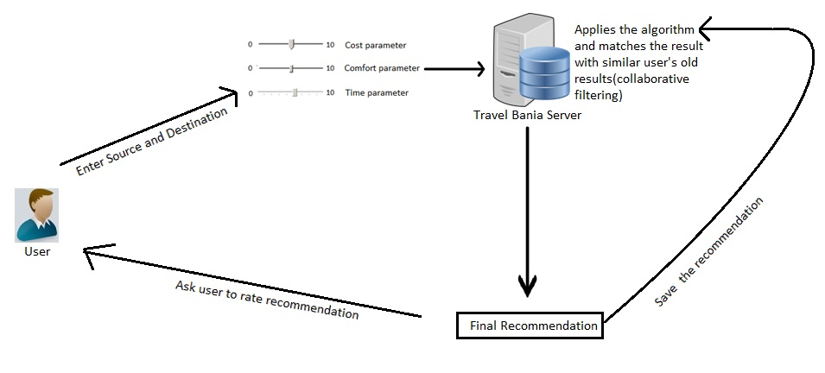

Fig 2. System architecture

**Chapter 4**

**IMPLEMENTATION, SIMULATION & RESULTS**

Screenshots of Knowledge based Algorithm and Output-

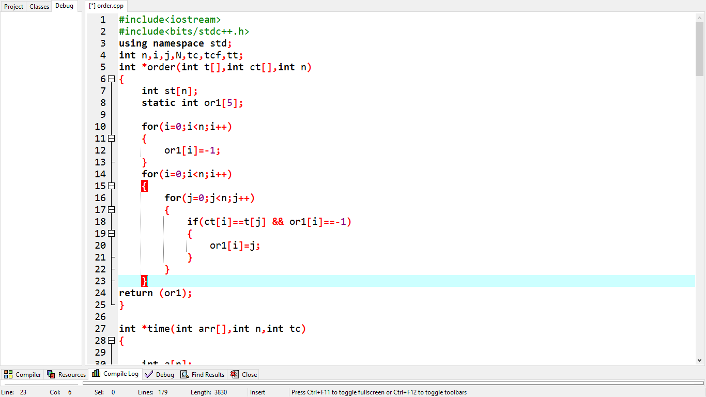

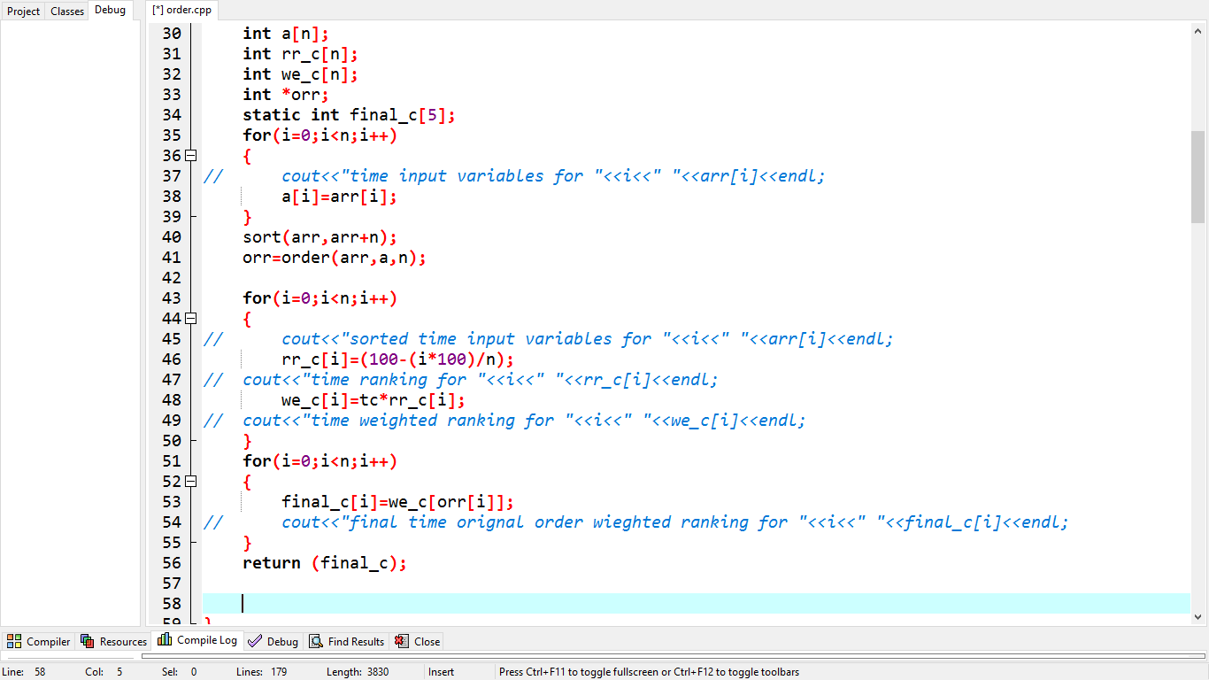

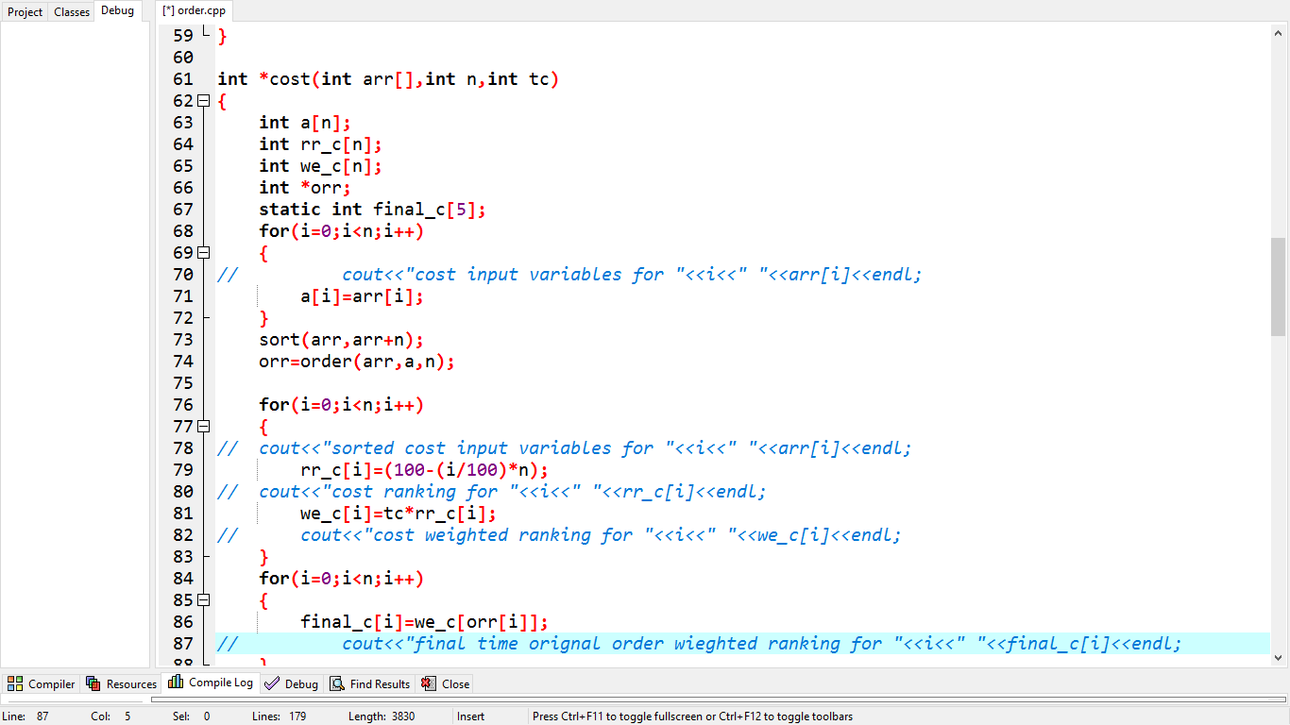

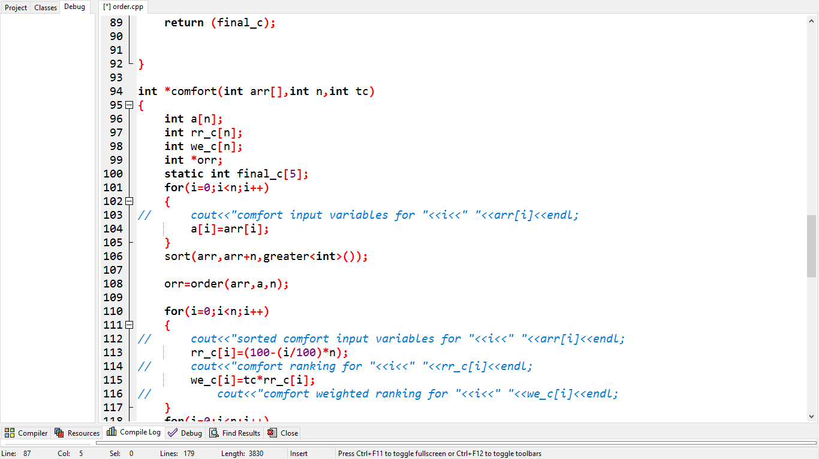

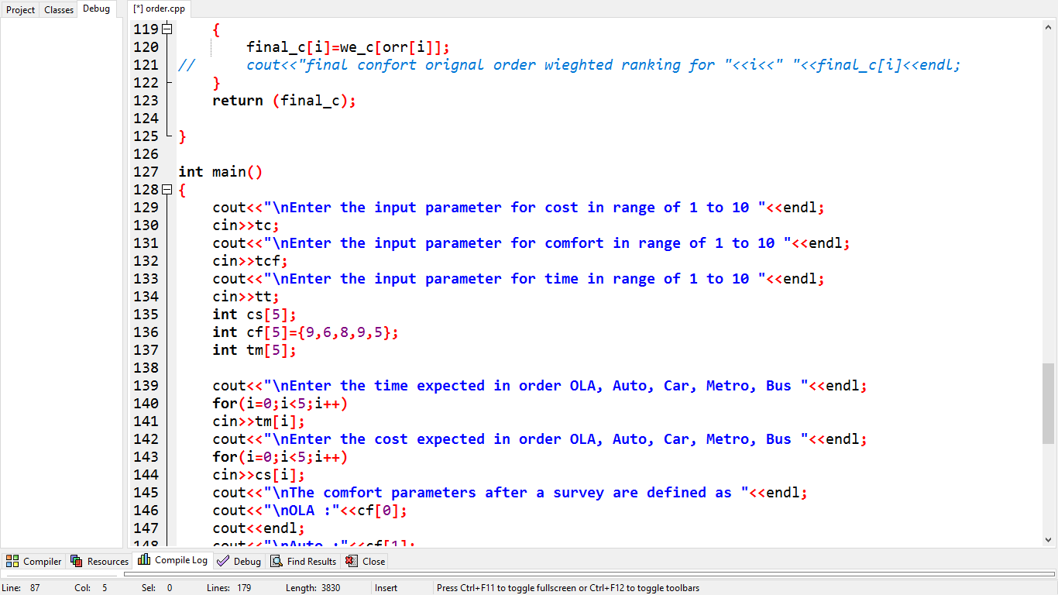

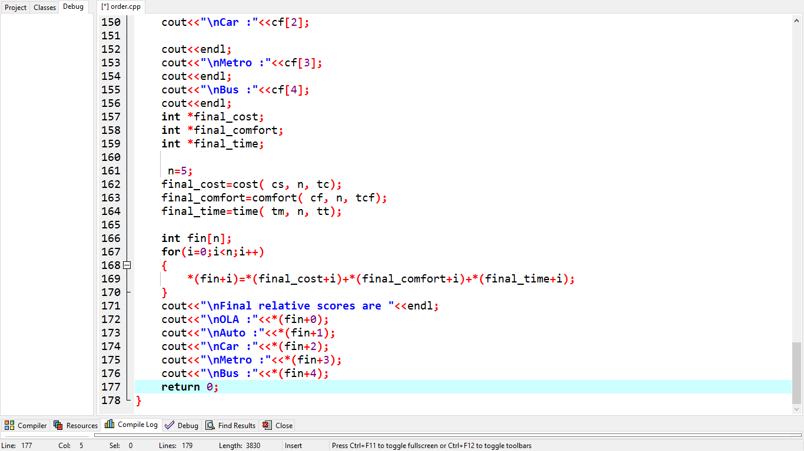

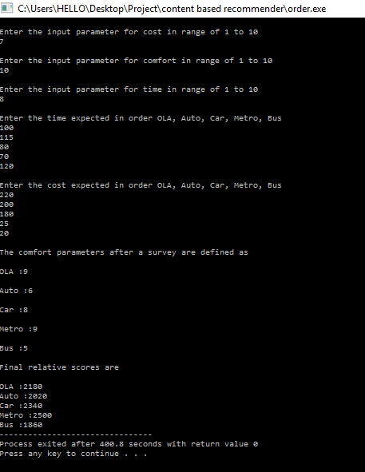

Screenshot of Collaborative Based Algorithm and Output-

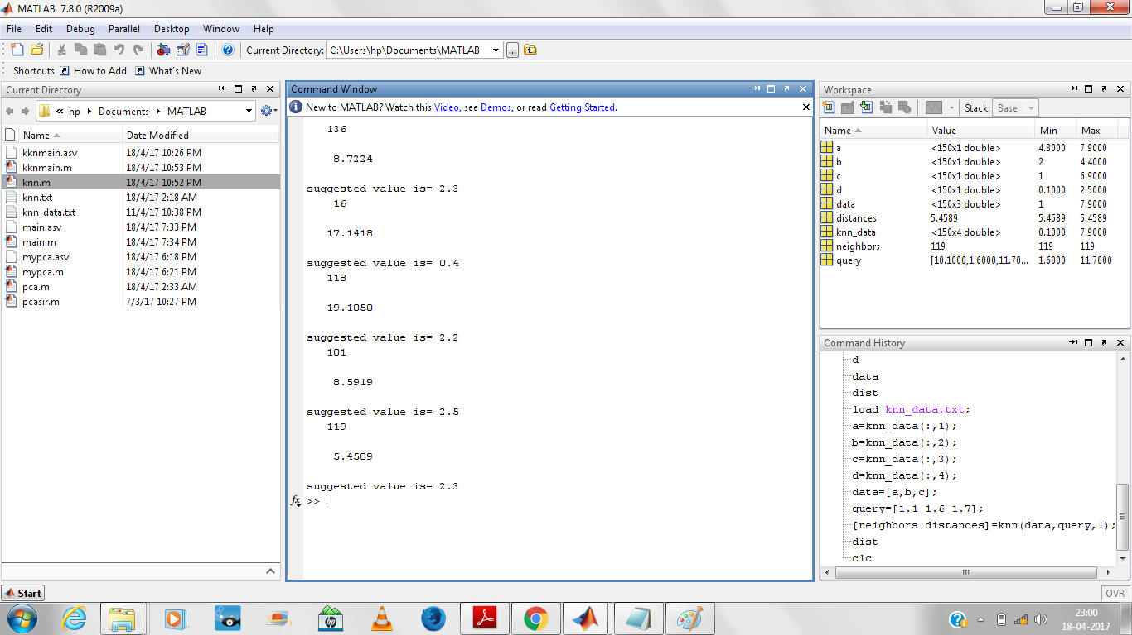

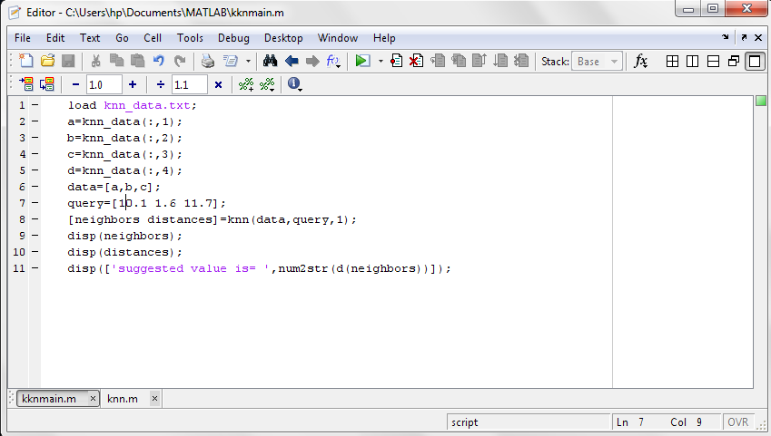

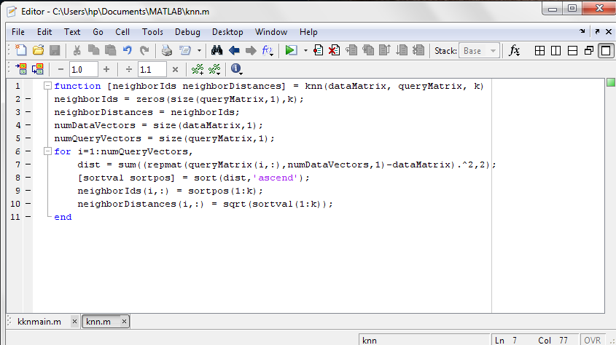

**Chapter 5**

**CONCLUSION AND FUTURE SCOPE**

A modern man spends considerable time in travel – either for business or for leisure purpose [3]. The person will have to choose between various modes of transports as he steps out. The best assistant a traveller possesses is the mobile device, he/she carries. Our Smart Transport Recommender System is directed to emptor of a smartphone and facilitates a location based utility that recommends the optimal mode of transport between two arbitrary points, on the basis of particular user preferences of cost, time and comfort. It not only recommends the best mode of transport but also the second best, third best and so on. Our project uses a hybrid approach (i.e. combination of multiple types of recommendation techniques) to suggest precise and faultless suggestions. Its main objective is to fulfil the user’s requirements.

**REFERENCES**

[1] Gytis Tumas, Francesco Ricci “*Personalized Mobile City Transport Advisory System”* Information and Communication Technologies in Tourism 2009 Proceedings of the International Conference in Amsterdam, The Netherlands, 2009 pp 173-183

[2] Alexis Lazanas “*Performing Hybrid Recommendation in Intermodal Transportation*” The FTMarket System’s Recommendation Module IJCSI International Journal of Computer Science Issues, Vol. 3, 2009

[3] Shini Renjith, Anjali C “*A Personalized Travel Recommender Model Based on Content-based Prediction and Collaborative Recommendation*” International Journal of Computer Science and Mobile Computing International Conference on Mobility in Computing- ICMiC13, Organized by Mar Baselios College of Engineering and Technology during December 17-18, 2013 at Trivandrum, Kerala, India, pg.66 – 73

[4] Anutosh Maitra, Saurabh Bhadkaria, Chiranjeeb Ghosh, Sanjoy Paul “*An integrated transport advisory system for commuters, operators and city control centres*” Vehicular Traffic Management for Smart Cities (VTM), 2012 First International Workshop during 20-20 Nov. 2012

[5] M Subramanyam , K. N. Ashwath kumar " *RLTS: Recommendation for Local Transportation System using Ambient Intelligence* " International Conference on Emerging Research in Electronics, Computer Science and Technology – 2015

[6] S. Canale, A. Di Giorgio, F. Lisi, M. Panfili, L. Ricciardi Celsi, V. Suraci, and F. Delli Priscoli *"A Future Internet Oriented User Centric Extended Intelligent Transportation System*" 24th Mediterranean Conference on Control and Automation (MED) June 21-24, 2016, Athens, Greece

[7] Prem Melville and Vikas Sindhwani "*Recommender Systems*" IBM T.J. Watson Research Center, Yorktown Heights, NY 10598

[8] Garvita Bajaj, Rachit Agarwal, Georgios Bouloukakis, Pushpendra Singh, Nikolaos Georgantas, Valerie Issarny "*Towards Building Real-Time, Convenient Route Recommendation System for Public Transit*" IEEE International Smart Cities Conference , Sep 2016, Trento, Italy. 2016.

[9] Robin Burke "*Integrating Knowledge-baseda and Collaborative-filtering Recommender Systems*" In Workshop on AI and Electronic Commerce, AAAI 1999

[10] R. Burke, “Knowledge-based Recommender Systems”, Encyclopedia of Library and Information Science, 69(32):180-200, 2000.

[11] Michael J. Pazzani and Daniel Billsus,.”Content-based Recommendation Systems”. In "The Adaptive Web: Methods and Strategies of Web Personalization" (Springer, LNCS #4321), February 1, 2007

[12] A. Paterek. "Improving regularized singular value decomposition for collaborative filtering". 2007:2–5, 2007 Statistics